## Criterion D: Product design—Overall structure

The following sketches depict how the product will work. These drawings are approved by the client: Mr. Giovino.

## Overall structure of website

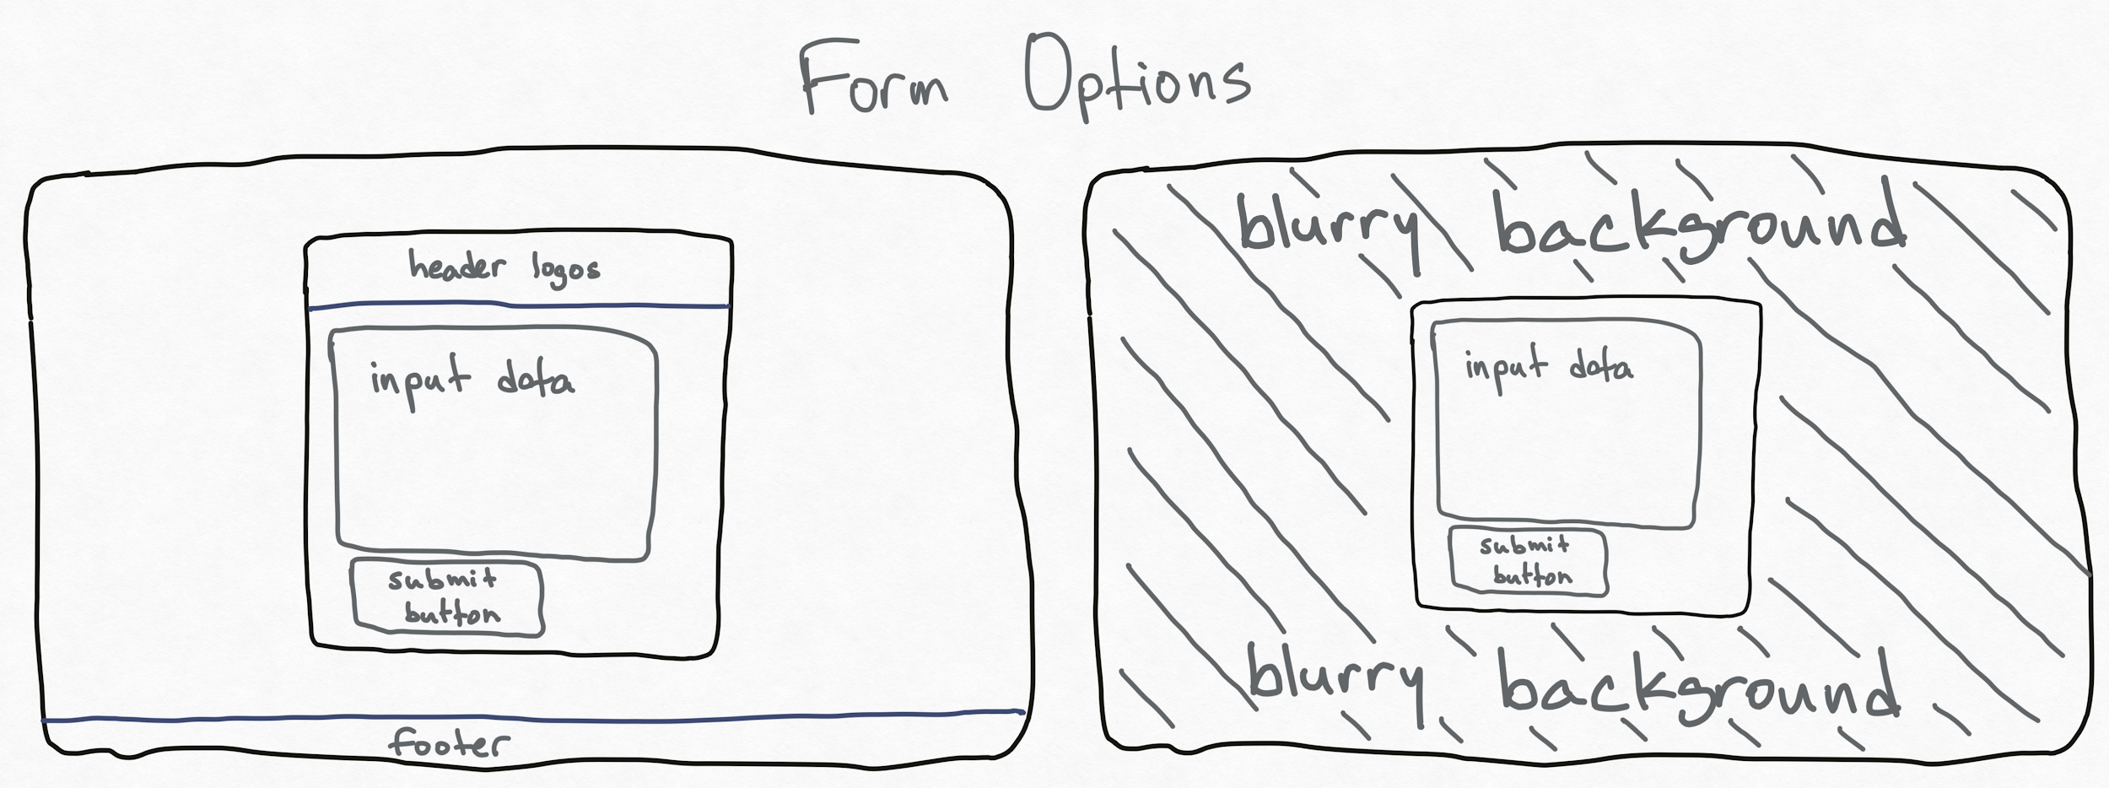

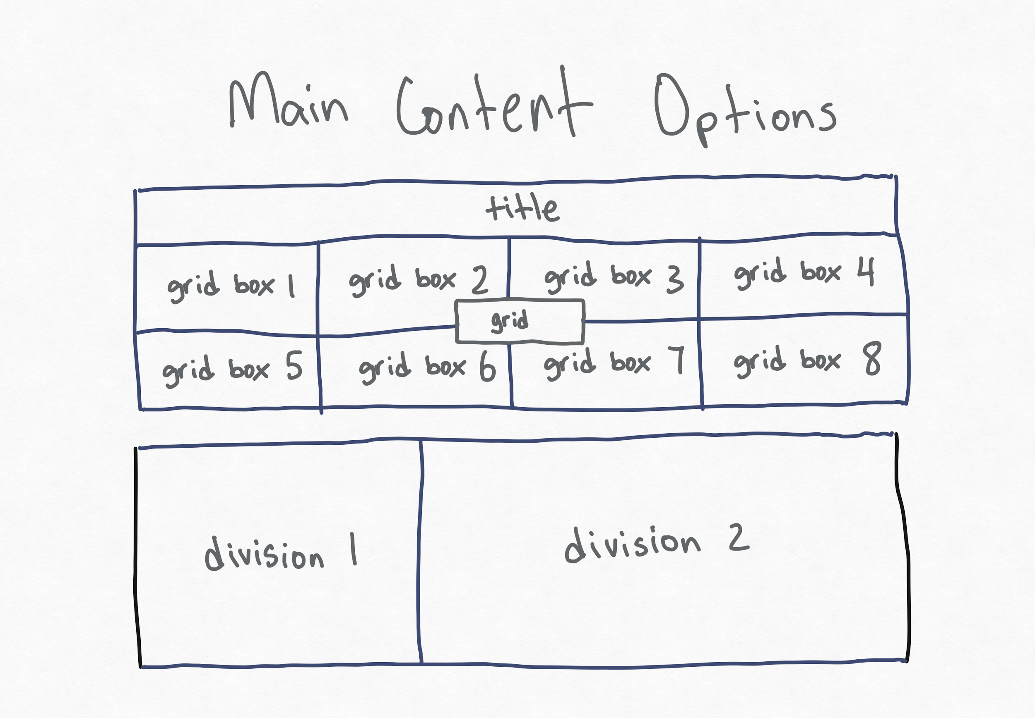

Entire Layout: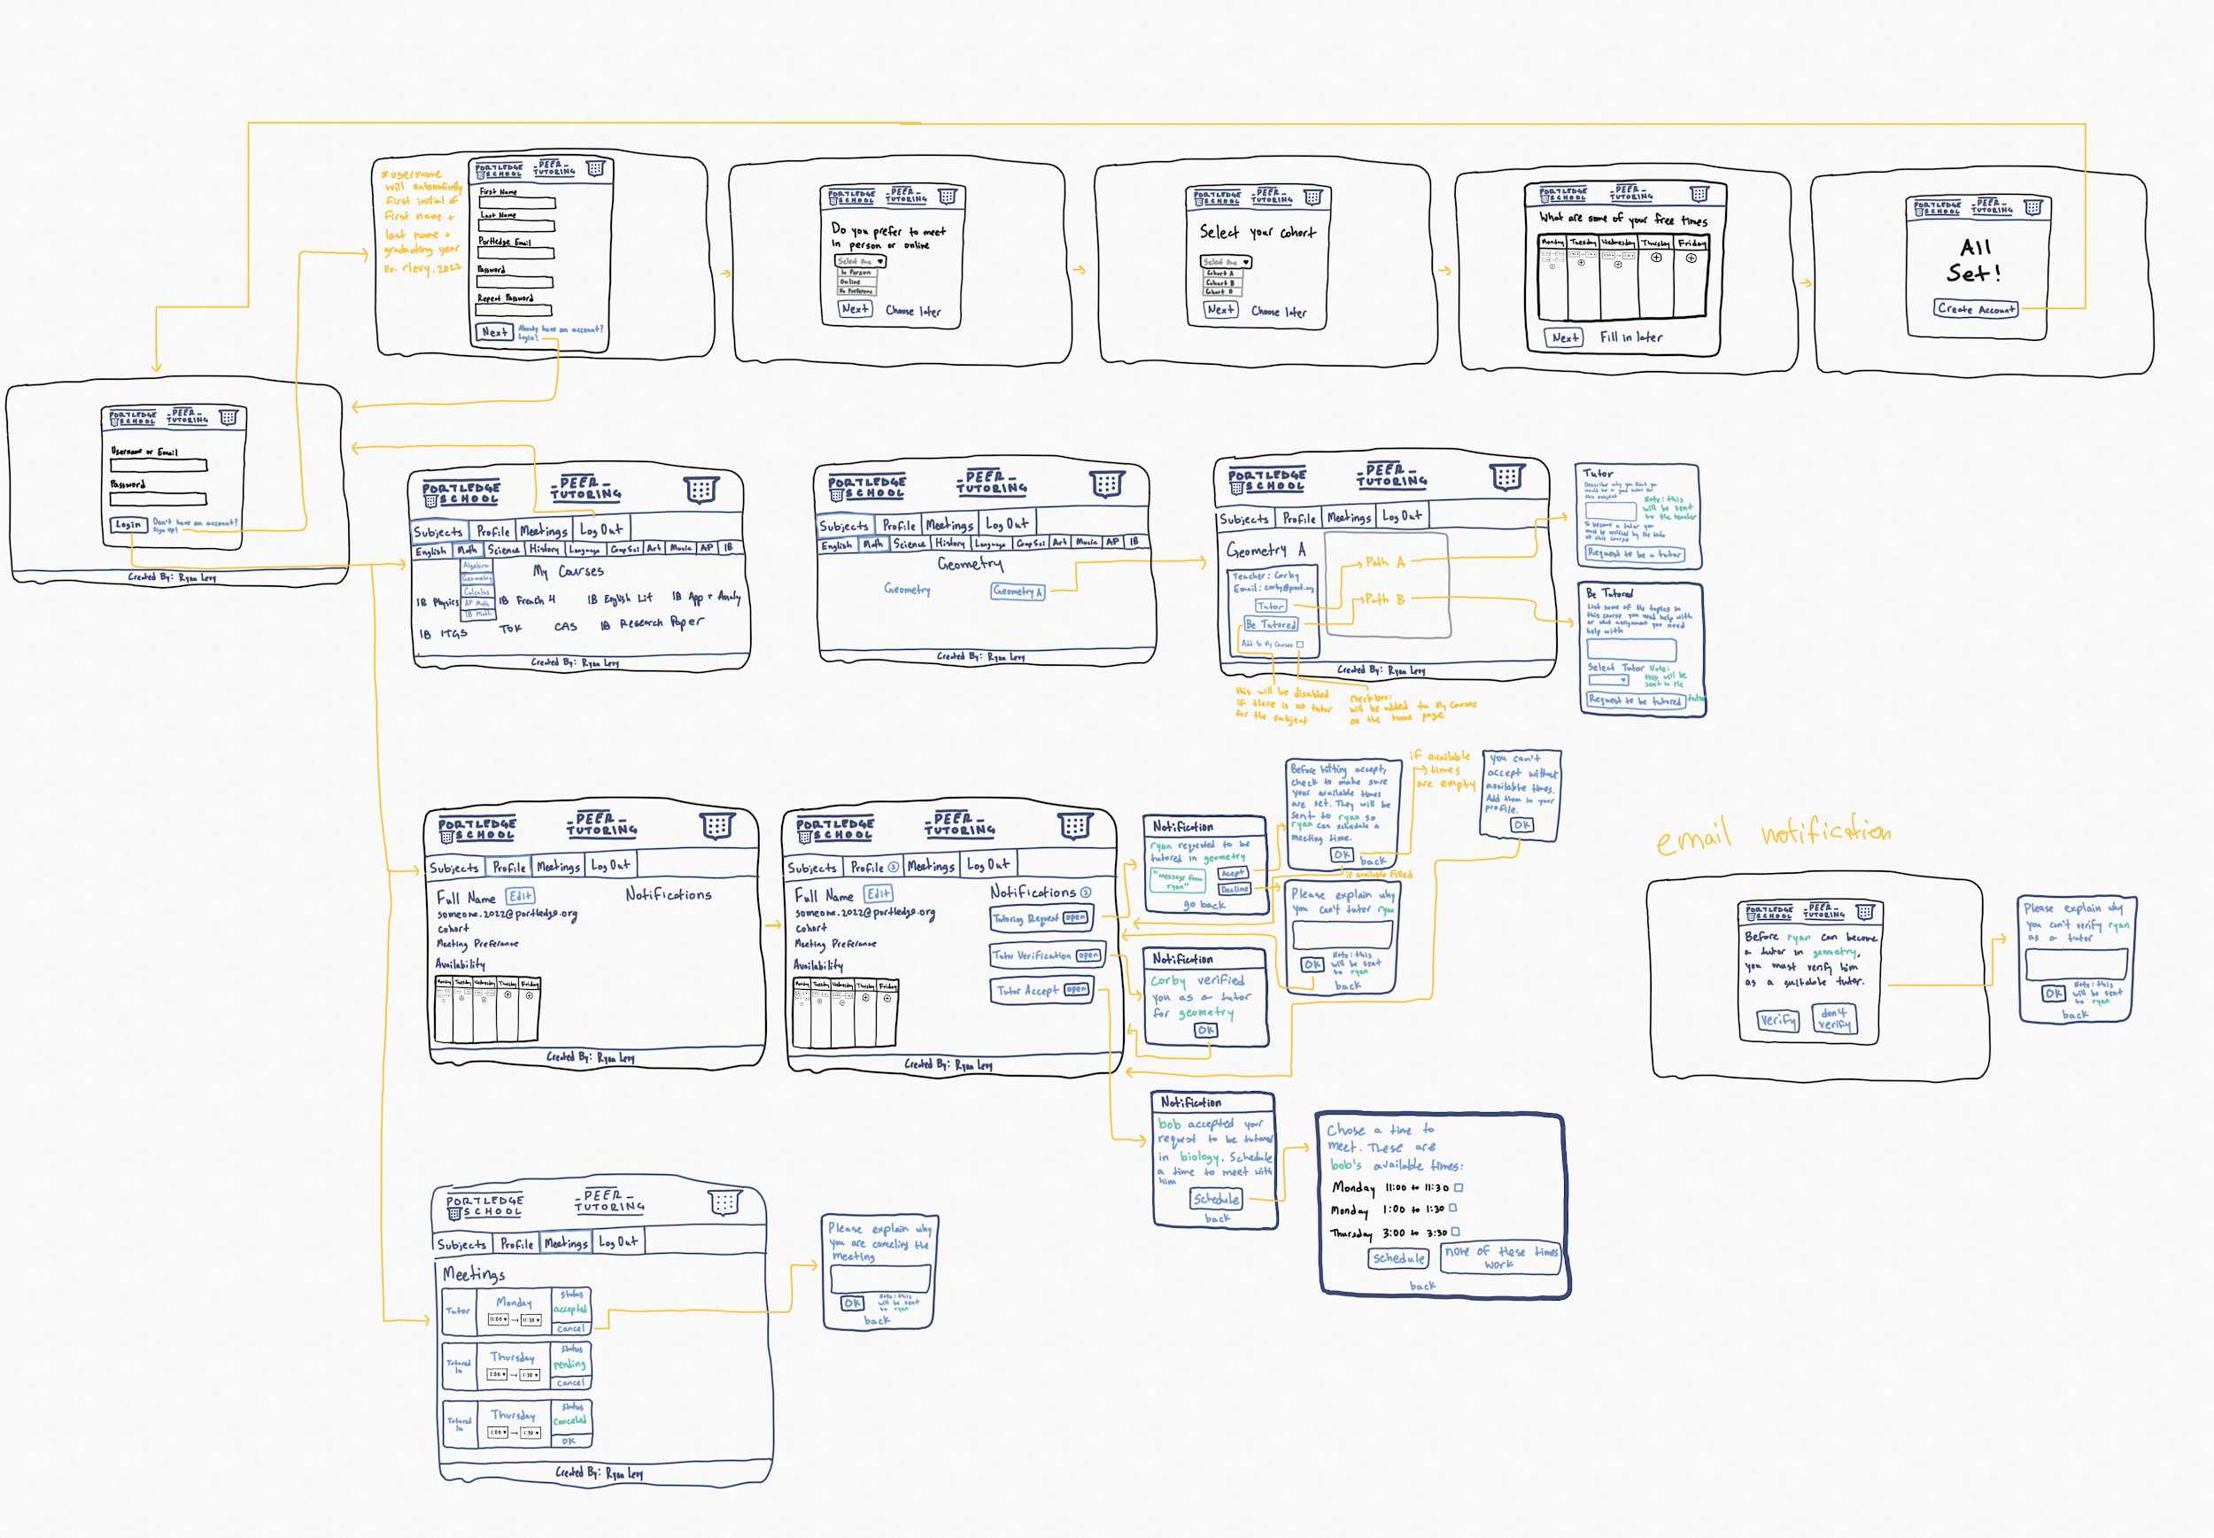

## Code Folders Layout:

| css | Includes css for the website |
| --- | --- |
| images | Holds website images |
| includes | These files are going to be named: ‘filename.inc.php’ just for a naming convention. These will handle form submissions, functions, and a connection to the database. |
| Other | Other files will not be in a folder |

## 

## Color Scheme:

* #00337f
* #d5dde4
* #dddddd
* #ffffff

## Internal structure

Database Name: peer_tutor

**Table Name: users**

| **Row** | user_id | user_first_name | user_last_name | user_username | user_password | user_email | user_cohort | user_meeting_preference |
| --- | --- | --- | --- | --- | --- | --- | --- | --- |
| **Description** | An auto increment id specific to the user | Users first name | Users last name | This will be automatically created once signed up. The structure of the username is (first initial of first name) + (last name) + (period) + (graduating year). The graduation year will come from their portledge email | User created password | Users portledge email. This MUST be their portledge email or they won’t be able to get email notifications | Users cohort: A, B, or O | Users meeting preference: In Person, Online, or No Preference |

**Table Name: user_availibility**

| **Row** | id | user_id | user_availible_day | user_availible_time_start | user_availible_time_end |
| --- | --- | --- | --- | --- | --- |
| **Description** | an identification to refer back to that will be specific to this cell | Denotes where the infor will be displayed (to which users page) | The day of the week the user is available | The start time of that day they user is available | The end time of that day they user is available |

**Table Name: courses**

| **Row** | id | course_name | subject_child | subject | teacher_name | teacher_email |
| --- | --- | --- | --- | --- | --- | --- |
| **Description** | an identification to refer back to that will be specific to this cell | The course name: [Algebra 1R, Algebra 1A, Geometry R, etc.] | this will be used if the subject has children topics. Ex. The subject children of Math could be [Algebra, Geometry, Calculus, AP, IB]. If there is none, it will default to [subject + ‘courses’] | The overall subject: [Math, English, Science, History, etc.] | The name of the teacher for this course | The teachers email |

**Table Name: user_courses**

| **Row** | id | user_id | my_courses_course_name |
| --- | --- | --- | --- |
| **Description** | an identification to refer back to that will be specific to this cell | Denotes where the infor will be displayed (to which users page) | The name of the course |

**Table Name: user_meetings**

| **Row** | id | user_id | meeting_tutor | meeting_student | meeting_day | meeting_time_start | meeting_time_end | meeting_status |
| --- | --- | --- | --- | --- | --- | --- | --- | --- |
| **Description** | an identification to refer back to that will be specific to this cell | Denotes where the infor will be displayed (to which users page) | The tutor in the meeting. This will be the tutors username | The student in the meeting. This will be the students username | The day of the meeting | The start time of the meeting | The end time of the meeting | The status of the meeting: [pending, canceled, accepted] |

**Table Name: user_notifications**

| **Row** | id | user_id | notification_type | notification_name | notification_info |
| --- | --- | --- | --- | --- | --- |
| **Description** | an identification to refer back to that will be specific to this cell | Denotes where the infor will be displayed (to which users page) | Type of notification: [tutor verified by teacher, tutor accepts student, student schedules meeting with tutor, student canceled meeting, tutor canceled meeting] | The name of the notification. This will be a shortened version of the notification type | The information that pops up when you click on the notification |

**Table Name: tutors**

| **Row** | tutor_id | user_id | class_id | verified |
| --- | --- | --- | --- | --- |
| **Description** | An auto increment id specific to the tutor | The id of the user | The id of the class they want to tutor in | this will either be true or false, this will change once the teacher of the course verifies (or does not verify) the student |

### List of resources and techniques

| **Resources** | **Details** | **Citation** |
| --- | --- | --- |
| **Visual Studio Code IDE** | I will use VSCode to write the source code for the product | “Visual Studio Code - Code Editing. Redefined.” *RSS*, Microsoft, 14 Apr. 2016, code.visualstudio.com/. |
| **XAMPP** | I will only use XAMPP to run the php and database locally on my computer. This includes an Apache Web Server and an SQL server. | “Apache Friends.” *Apache Friends RSS*, www.apachefriends.org/index.html. |
| **PhpMyAdmin** | I will only use PhpMyAdmin to run the database locally on my computer | contributors, phpMyAdmin. *PhpMyAdmin*, www.phpmyadmin.net/. |
| **Youtube Videos** | I will use youtube tutorial to learn php basics and web deployment | TheCharmefis. “1: Introduction To PHP | Procedural PHP Tutorial For Beginners | PHP Tutorial | Mmtuts.” *YouTube*, YouTube, 20 Apr. 2020, www.youtube.com/watch?v=XBj_le81sAc. |
| **W3School** | I will use this website for html, css, and other php help | “HTML.” *W3Schools Online Web Tutorials*, www.w3schools.com/. |
| **Dani Krossing Php login system tutorial** | I used these youtube tutorials to learn how to build a login/signup system. I have made modifications to this code for my own usage and will build the product on top of this login system.  [How To Create A Login System In PHP For Beginners | Procedural MySQLi | PHP Tutorial](https://www.youtube.com/watch?v=gCo6JqGMi30)  [How To Create A Forgotten Password System In PHP | Password Recovery By Email In PHP | PHP Tutorial](https://www.youtube.com/watch?v=wUkKCMEYj9M&t=1213s) | TheCharmefis. “How To Create A Login System In PHP For Beginners | Procedural MySQLi | PHP Tutorial.” *YouTube*, YouTube, 11 Oct. 2020, [www.youtube.com/watch?v=gCo6JqGMi30](http://www.youtube.com/watch?v=gCo6JqGMi30).  TheCharmefis. “How To Create A Forgotten Password System In PHP | Password Recovery By Email In PHP | PHP Tutorial.” *YouTube*, YouTube, 28 Nov. 2018, www.youtube.com/watch?v=wUkKCMEYj9M&t=1213s. |
| **MyPortledge and Portledge.org** | I will use these websites for design inspiration as I am creating the website for portledge school. | *Portledge.myschoolapp.com*, portledge.myschoolapp.com/app/student#studentmyday/assignment-center.  “Portledge School: Pre-Nursery - Grade 12: Locust Valley, NY.” *Portledge School | Pre-Nursery - Grade 12 | Locust Valley, NY*, www.portledge.org/. |
| **Portledge Branding Guide** | I will also use this websites for design inspiration | Portledge School, Brand & Visual Style Guide, 2016-2017 |

| **Techniques** | **Details** |
| --- | --- |
| Arrays, including appending to $_POST, $_GET, and $_SESSION | Using php $_POST, $_GET, and $_SESSION variables |
| Subroutines, parameter passing | Having multiple subroutines to make running the same code more efficient |
| Structures Query Language (SQL) to develop back-end database | Have multiple tables to have the website remember data. Use functions such as AUTO-INCREMENT, INSERT, and SELECT |
| Cascading style sheets (CSS) or schema | Proficient use of css and create responsive pages with media queries |

## Test plan

| Test item | Test data | Part of system tested | Expected outcome | Actual outcome | Comments | Ref in product |
| --- | --- | --- | --- | --- | --- | --- |
| **Cover page testing – REQUIRED ELEMENT FOR CRITERION G** | | | | | | |
| Web pages load from the cover page in three different locations | File naming to ensure home page is called Index.htm | Links on cover page are relative | Loads as required from 3 different locations | **Yes** | **index.html loads login page or subjects page if session is still continuous** | index.html |
| **Product testing** | | | | | | |
| Create Account | first name, last name, email, password, repeat password, cohort, meeting preference, available times {start time, end time, day} | sign-up.php,  user-cohort.php, user-meeting-preference.php,  user-availability.php,  includes/sign-up.inc.php,  includes/user_cohort.inc.php,  includes/user-availability.inc.php,  includes/user-meeting-preference.inc.php,  includes/connection.inc.php,  includes/functions.inc.php | Adds a row to the user database | **Yes** | **User can create their own account through a multi-page form** | createUser(),  updateProfile(),  createAvailability(), |
| Login | username, email, password | index.php,  login.php,  includes/login.inc.php,  includes/connection.inc.php,  includes/functions.inc.php | Logs in correctly and shows users data | **Yes** | **User can enter their username or email and their password to log in** | loginUser() |
| Navigate to pages | hyperlinks | header.php,  subjects.php,  login.php,  meeting.php,  profile.php,  includes/logout.inc.php | Shows desired page when clicked on link | **Yes** | **The user can navigate to multiple pages through the navigation in the header** | header.php lines 29-40 |
| Forgot Password | n/a | n/a | Creates new password and gets email verification | **No** | **I was not able to setup an email server to then send a forgot password link to user** | n/a |
| Change Profile Settings | first name, last name, email | profile.php,  includes/edit-profile.inc.php,  includes/edit-add-available-times.inc.php,  includes/connection.inc.php,  includes/functions.inc.php | Creates an updated profile page | **Yes** | **Using JQuery to show/hide input elements to edit profile** | course-page.php lines 19-31 |
| Navigate to Subjects | hyperlinks | subject-topic-page.php | Displays subject page | **Yes** | **The navigation of classes is taken from a database of all Portledge classes** | subjects.php lines 17-111 |
| Navigate to Specific Course | hyperlinks | subjects.php,  course-page.php,  includes/connection.inc.php,  includes/functions.inc.php | Displays course page | **Yes** | **This navigation is also taken from the database table for the courses** | subjects.php lines 17-111 |
| Show Course/Subject Information | hyperlinks | header.php,  course-page.php,  includes/connection.inc.php,  includes/functions.inc.php | Shows the hyperlinks to the subject or course page | **Partially** | **I was able to show the course name, but I did not have the resources to show the teacher’s name/email on the page** | getCourseData() |
| Submit request to be a tutor | user id, course id, description | course-page.php,  includes/tutor-request.inc.php,  includes/connection.inc.php,  includes/functions.inc.php | Open form to submit to be a tutor, email will be sent to teacher to verify | **Partially** | **I was not able to get an email server to send an email to the teacher. This was solved by having every tutor be verified** | createNonVerifiedData() |
| Submit request to be a student | user id, tutor id, course id, description | course-page.php,  includes/be-tutored-request.inc.php,  includes/connection.inc.php,  includes/functions.inc.php | If tutors are available, open form to submit to be a student | **Yes** | **Tutor is able to accept student** | createStudent() |
| Verify Student | notifications | profile.php,  includes/connection.inc.php,  includes/functions.inc.php | Receive notification that will redirect you to a form where you can verify a student as a tutor | **Yes** | **After certain functions, such as requesting to be a student, and notification is sent to the tutor to either accept or decline the student** | getNotifications(),  parseNotifications() |
| Send Data to SQL Database | multiple data points | includes/connection.inc.php,  includes/functions.inc.php | Manipulate, update, insert data into database | **Yes** | **I was able to send data to the database through different functions, such and login and sign up** | includes/functions.inc.php |
| Get Data to SQL Database | multiple data points | includes/connection.inc.php,  includes/functions.inc.php | Receive data from specific tables in the database | **Yes** | **I received data from the database to show the users specific information, such as their profile page information** | includes/functions.inc.php |

## Agreement of client

**(Client)**

I confirm that the requirement specification meets my needs and the designs above are appropriate for the creation of the product.

